**Only Vmware:**

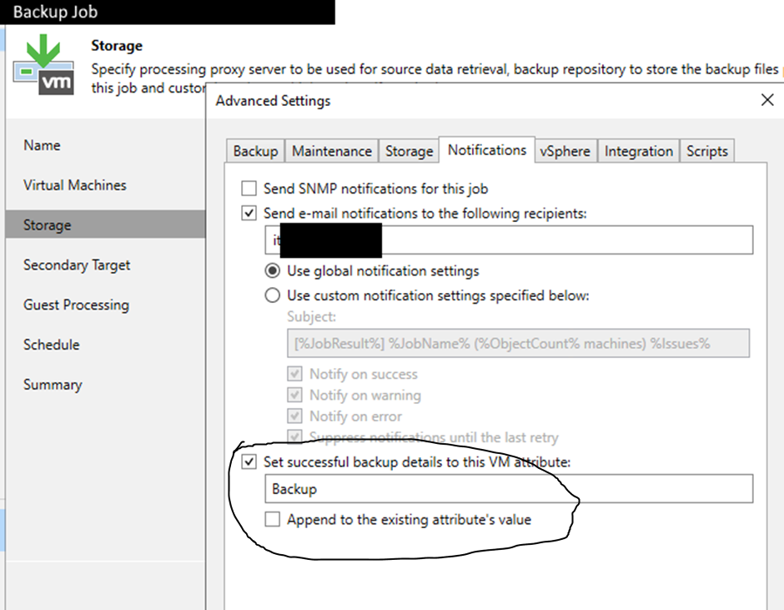

**Only Hyper-V:**

create AD User and group

Ad Group to

see: [PowerShell: Implementing Just-Enough-Administration (JEA), Step-by-Step – SID-500.COM](https://sid-500.com/2018/02/11/powershell-implementing-just-enough-administration-jea-step-by-step/)

New-PSSessionConfigurationFile -Path 'C:\_adminfiles\dauerhaft\hv_conf.pssc'

Edit this File:  
change Author (line 10)  
change Session Type (Line 16) to RestrictedRemoteServer  
enable RunAsVirtualAccount (Line 22)   
configure RoleDefinitions (Line 28)  
RoleDefinitions = @{ 'domain\read-hyperv-server' = @{ 'RoleCapabilities' = 'HVread' }}  
Add:   
**ModulestoImport = ‘Hyper-V’**

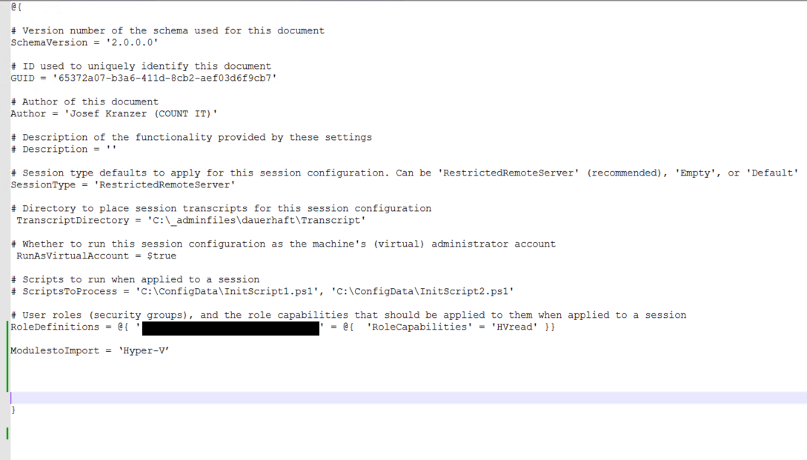

New-Item -Path 'C:\Program Files\WindowsPowerShell\Modules\JEA\RoleCapabilities' -ItemType Directory

New-PSRoleCapabilityFile -Path 'C:\Program Files\WindowsPowerShell\Modules\JEA\RoleCapabilities\HVread.psrc’  
  
Maybe change Author (7), ComanyName(13) and Copyright (16)

Change VisibleCmdlets (Line 25) to:  
VisibleCmdlets = @{

Name = 'Get-VM'

Parameters = @(

@{

Name = '*'

}

)

}

Register-PSSessionConfiguration -Name HVread -Path 'C:\_adminfiles\dauerhaft\hv_conf.pssc’

Restart-Service WinRM

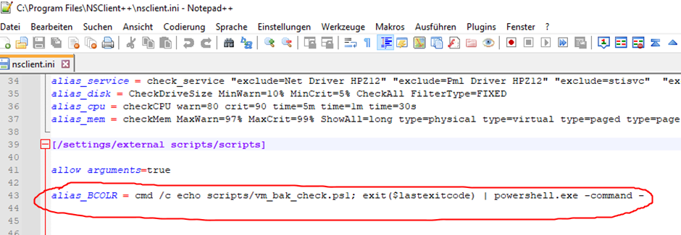

alias_BCOLR = cmd /c echo scripts/vm_bak_check.ps1; exit($lastexitcode) | powershell.exe -command -

